Preparing data

|  |  |
| --- | --- |
| Team ID | PNT2022TMID13572 |
| Project Name | Global Sales Data Analytics |

Data Preparation

(Uploaded DataSet)

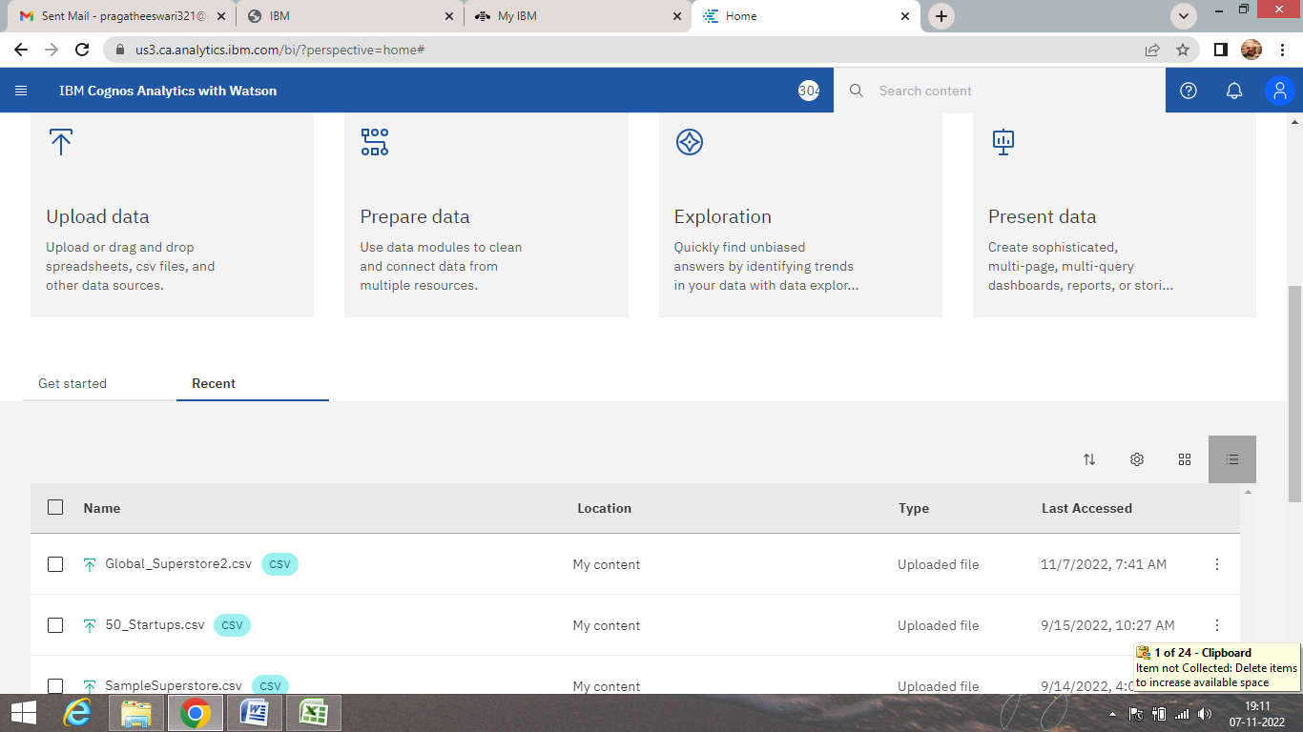

DataSet

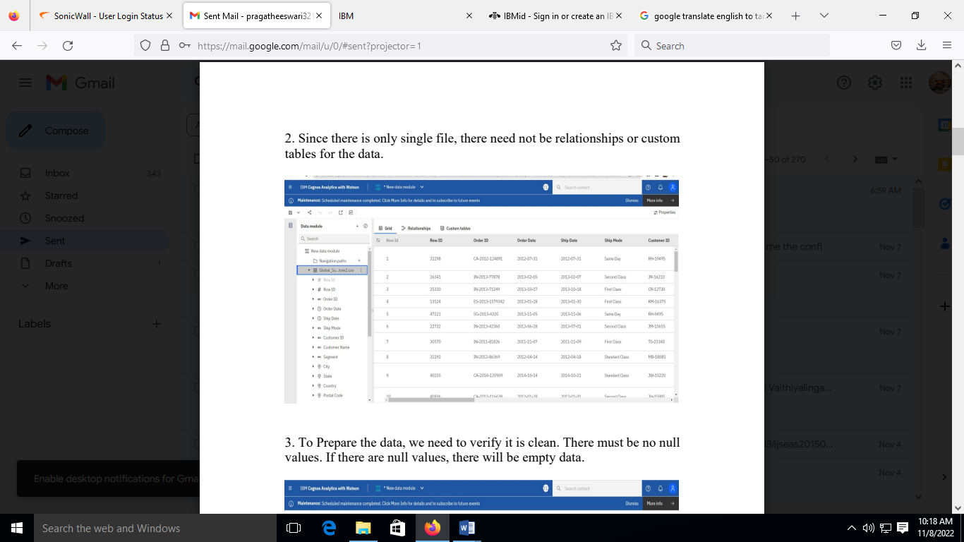

For Prepare the data, we verify whether the null values are present or not.

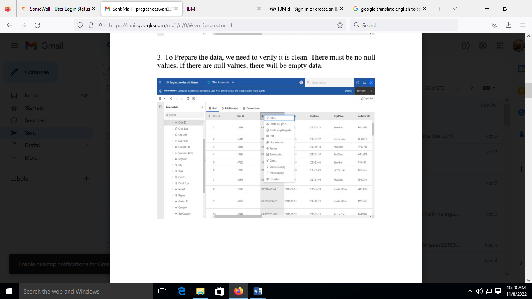

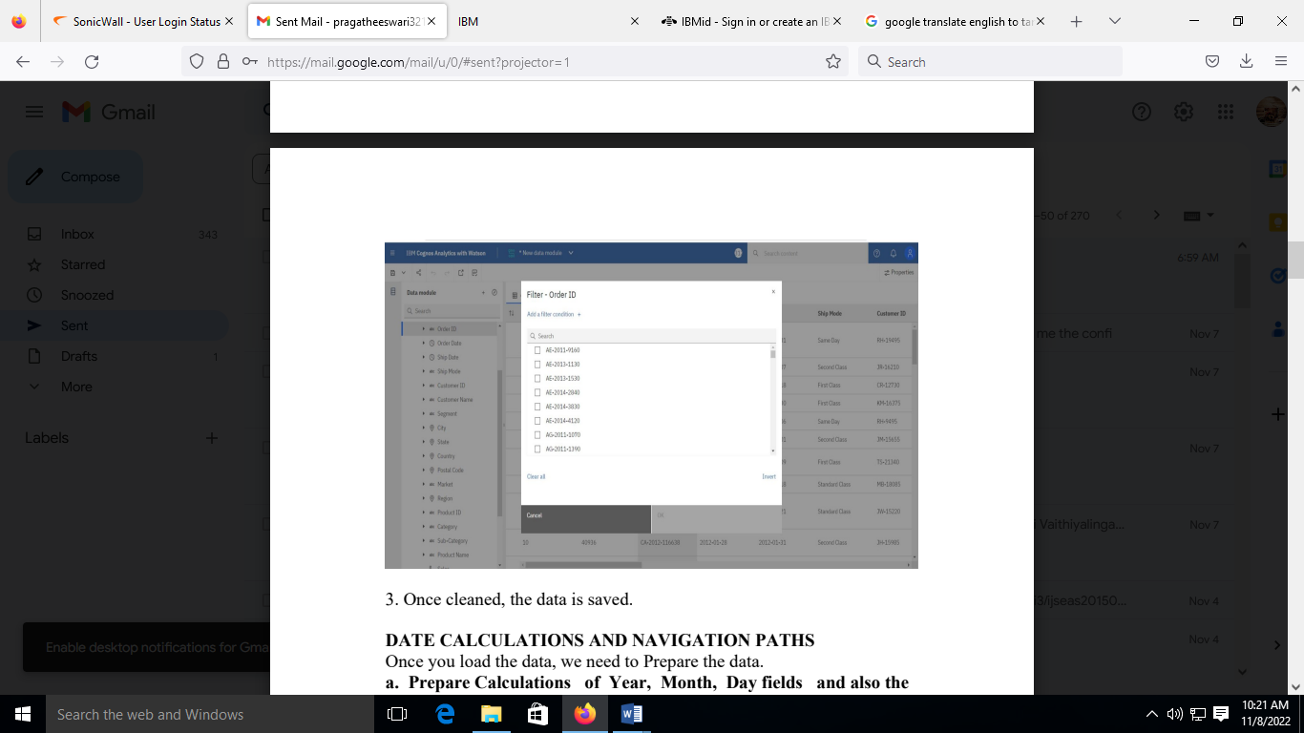

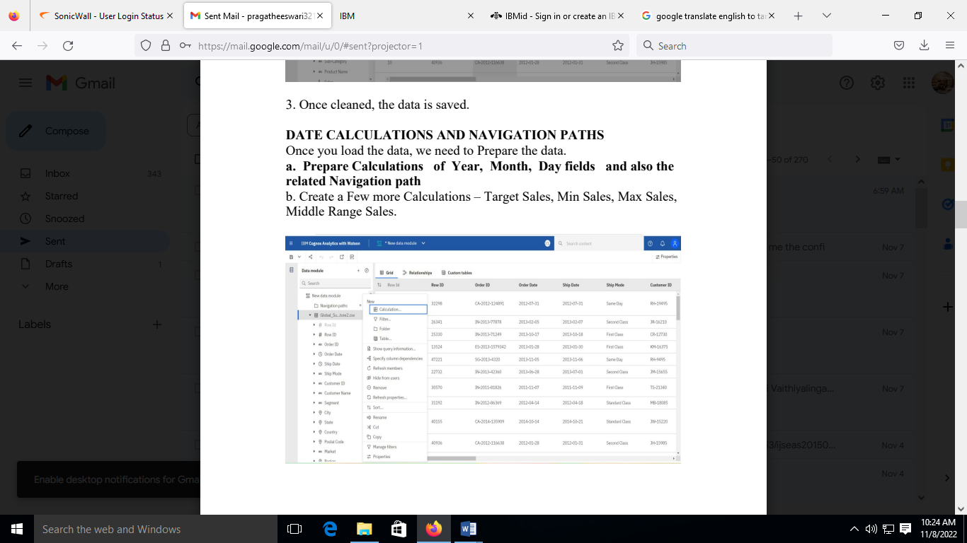

**Calculations of Year, Month, Day fields and also the related Navigation path :**

Right click -> calculation -> type expression -> validate -> Set Name as

‘Order_Year’

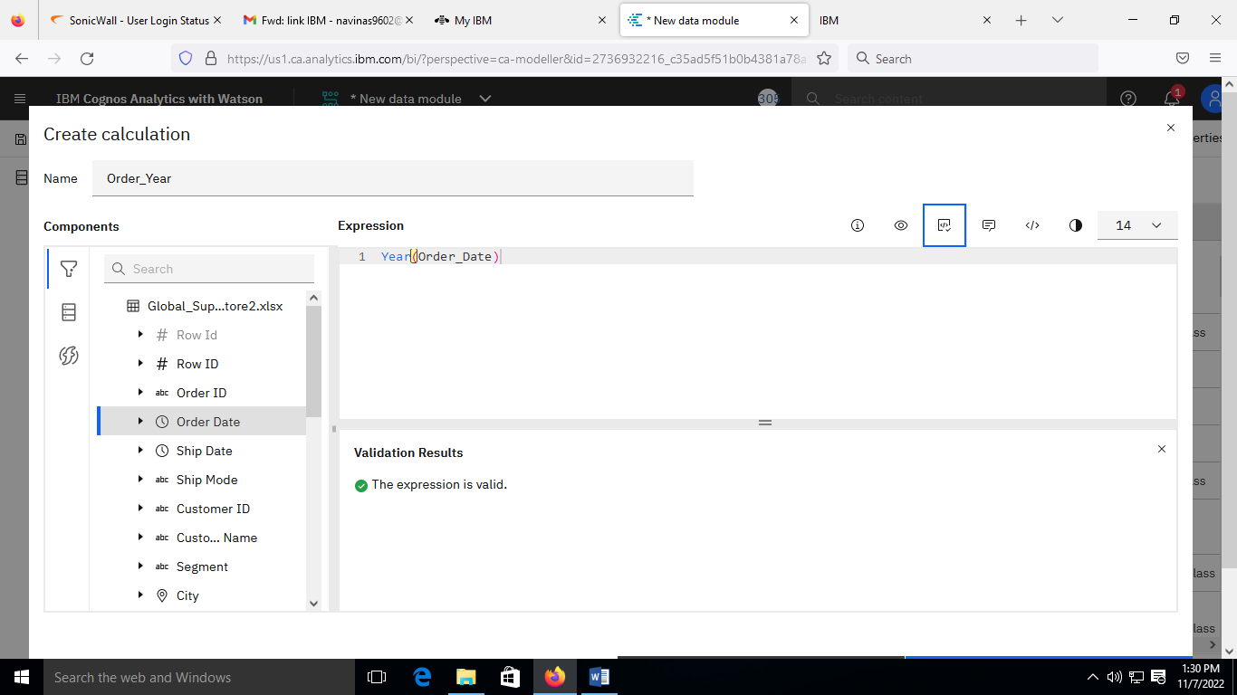

Right click -> calculation -> type expression -> validate -> Set Name as

‘Order_Month’

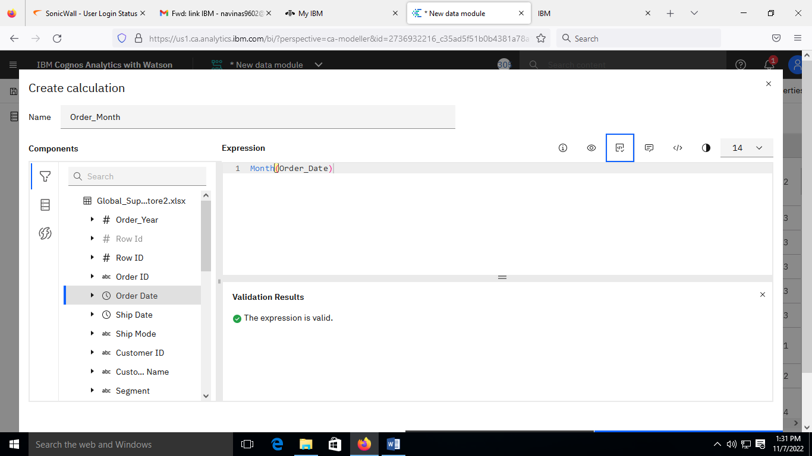

Right click -> calculation -> type expression -> validate -> Set Name as

‘Order_Day’

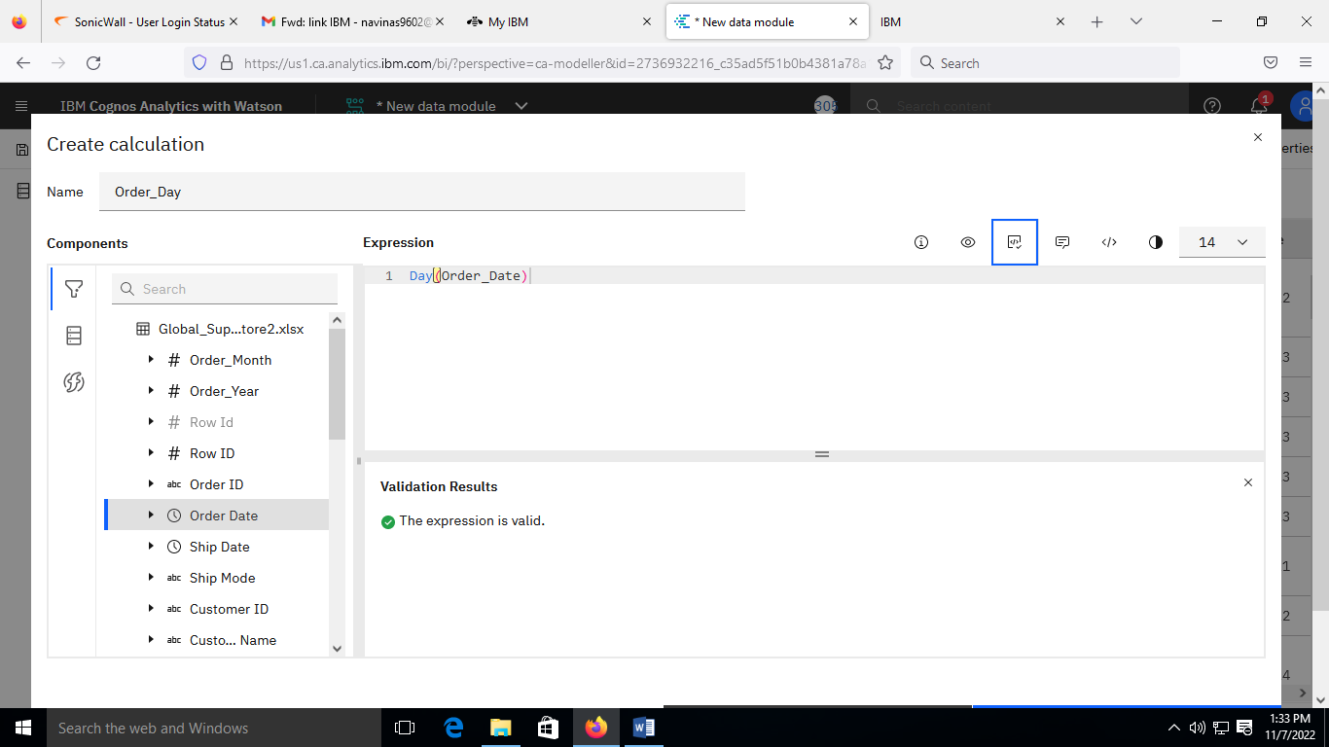

Right click -> calculation -> type expression -> validate -> Set Name as

‘All’

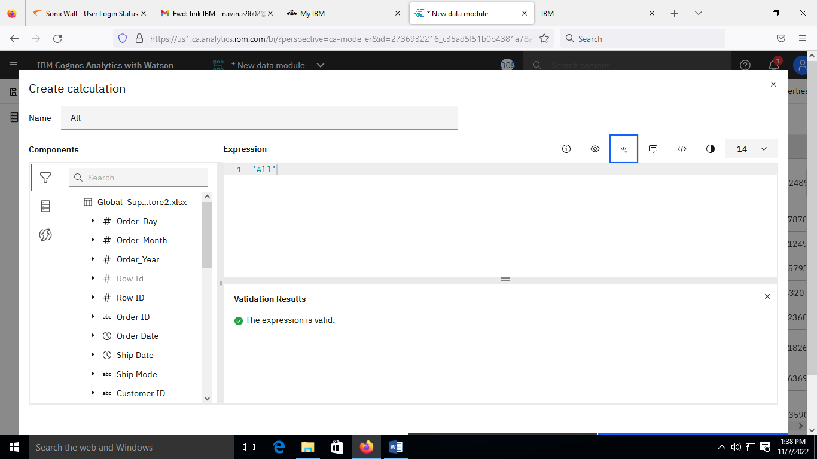

Properties -> Usage-> Attribute

Aggregate -> Count Distinct

Data Type -> Integer

Represents -> Time, (Year, Month, Day Respectively)

Display Options -> Show Members

This way it becomes a Numerical data Type

Right click on create navigation path

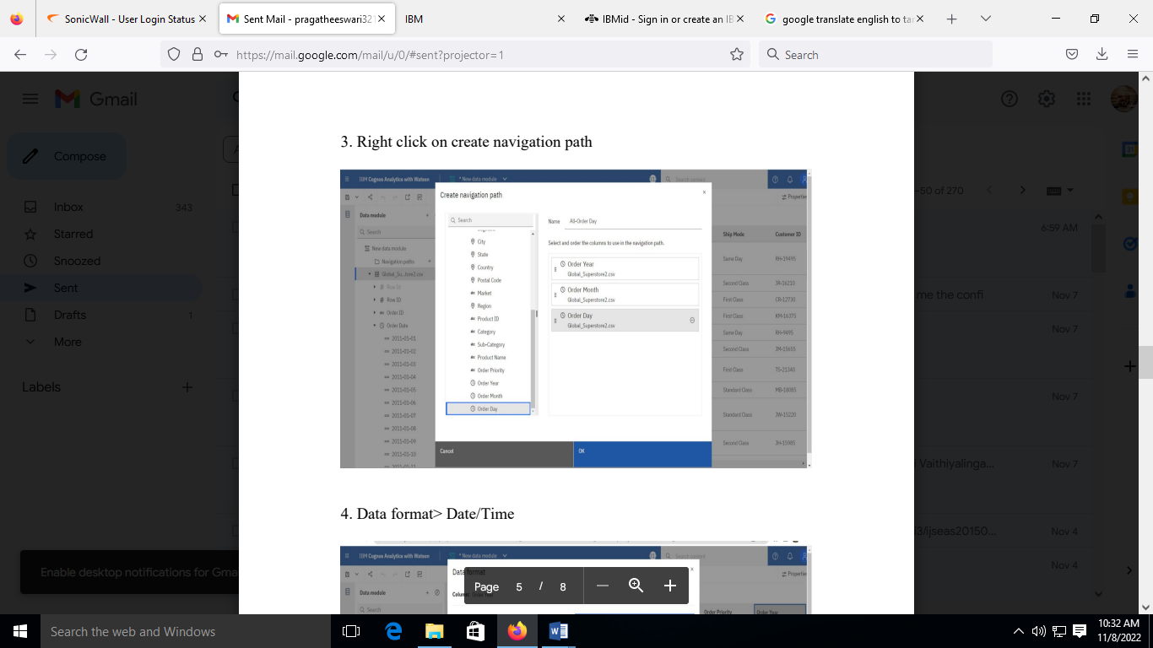

Data format> Date/Time

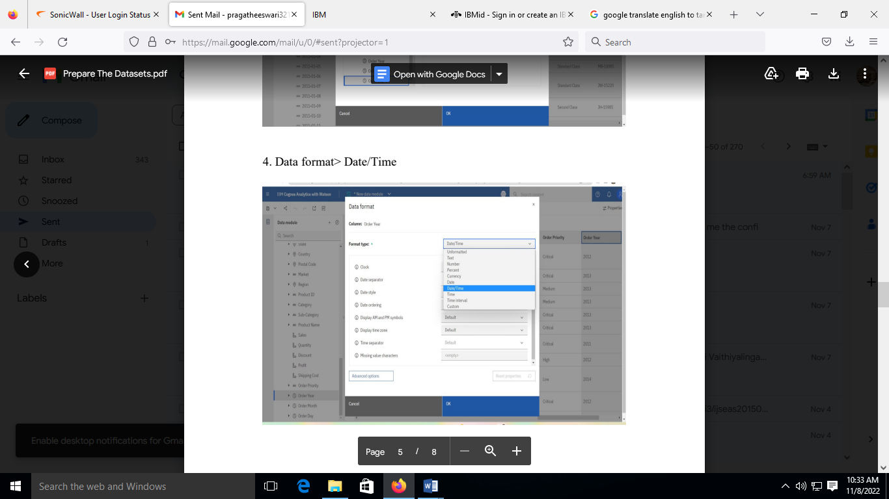

**Calculations for Target sales, Min sales, Max Sales and Middle range sales** Min sales -> minimum (Sales)

Max sales, Target sales -> maximum (Sales)

Middle range sales -> average (Sales)

Minimum sales :

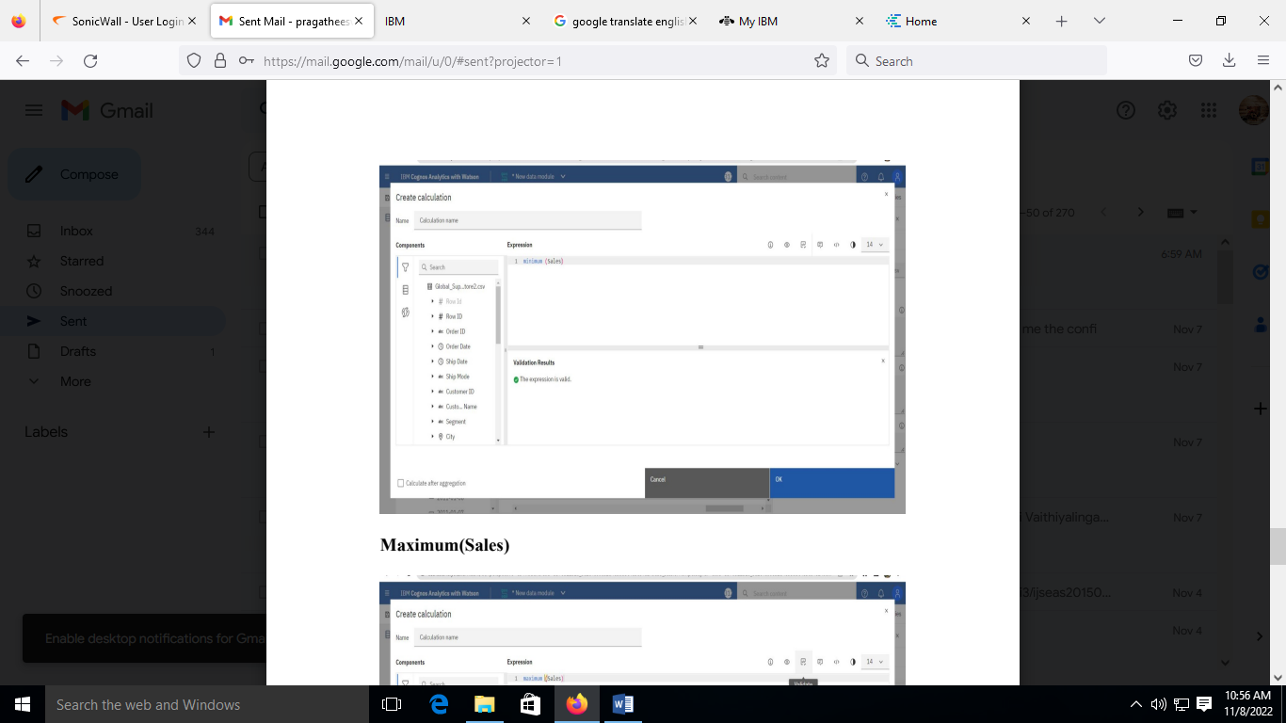

Maximum Sales :

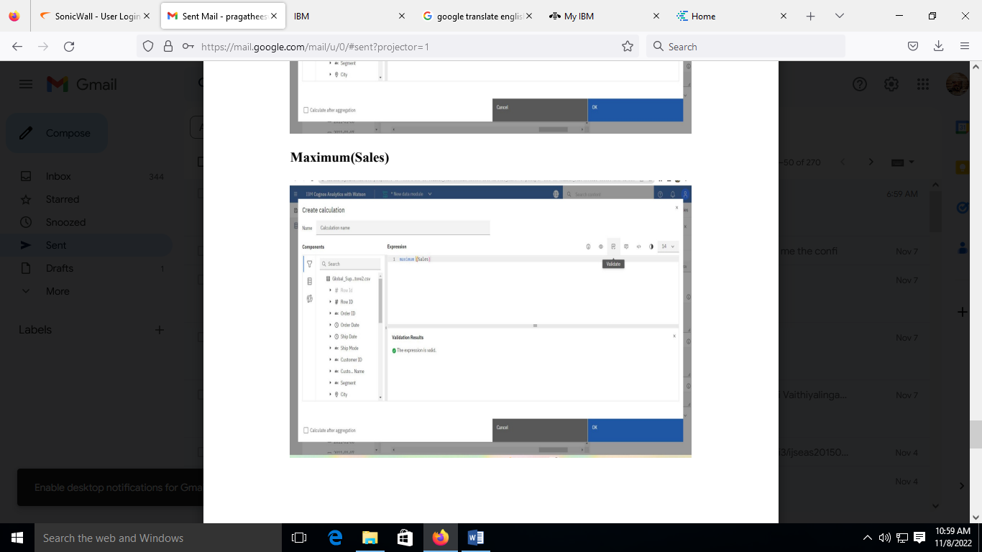

Middle Range sales :

